BUSINESS INSIGHT REPORT
NORTHWIND TRADERS – SALES & FINANCIAL PERFORMANCE
Title: Business Insight Report

Student Name: Monish Kumar .N
Course / Class:B.com Fintech With Ai

1. Introduction
This report analyses the Northwind Traders sales dataset using the uploaded Power BI report. The dashboard is designed to give a quick view of orders, quantity sold, freight, customers, product categories and employee performance. The purpose of this report is to convert the dashboard visuals into clear business observations and practical recommendations.
The uploaded PBIX contains an Interactive Sales Dashboard together with Sales Overview and Product & Customer Analysis pages. The dashboard uses interactive filters for year, category and country/region, allowing users to examine how the KPIs and charts change when a filter is applied.

2. Dashboard Overview
The dashboard snapshot below is a report-ready reconstruction of the uploaded PBIX page layout. It follows the actual visual structure identified in the PBIX: five KPI cards, category slicer, region/country slicer, year slicer, employee-order chart, monthly-order chart and sales-by-category chart.
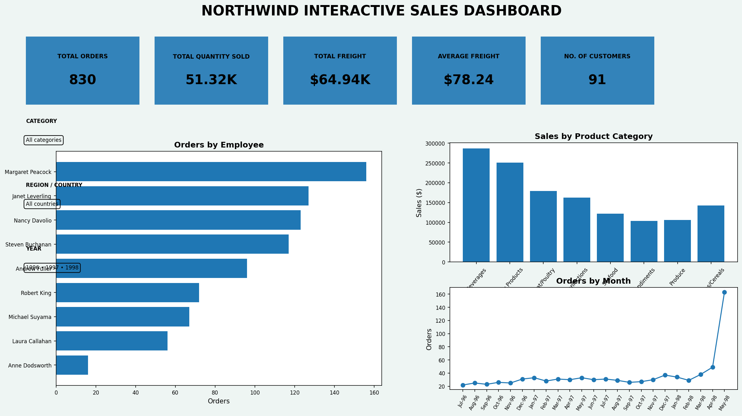
Figure 1. Northwind Interactive Sales Dashboard – report snapshot
Key dashboard components: KPI cards for Total Orders, Total Quantity Sold, Total Freight, Average Freight and Number of Customers; Orders by Month; Sales by Product Category; Orders by Employee; and interactive filters for year, category and region/country.

3. KPI Analysis
KPI | Value | Interpretation
Total Orders | 830 | Overall order activity across the dataset.
Total Quantity Sold | 51,317 | Total units represented in order details.
Total Freight | $64.94K | Aggregate freight/shipping cost.
Average Freight | $78.24 | Average freight cost per order.
No. of Customers | 91 | Unique customer coverage in the dataset.
Overall, the dashboard represents a substantial order base with 830 orders, 51,317 units sold and 91 customers. Freight is also a visible operating cost, with total freight of about $64.94K and an average of about $78.24 per order.

4. Product Category Performance Analysis
The Sales by Product Category visual compares the contribution of the eight Northwind categories. Beverages is the highest-selling category in the dashboard analysis, while the remaining categories form a second tier of contributors. The differences show that demand is not evenly distributed across the product portfolio.
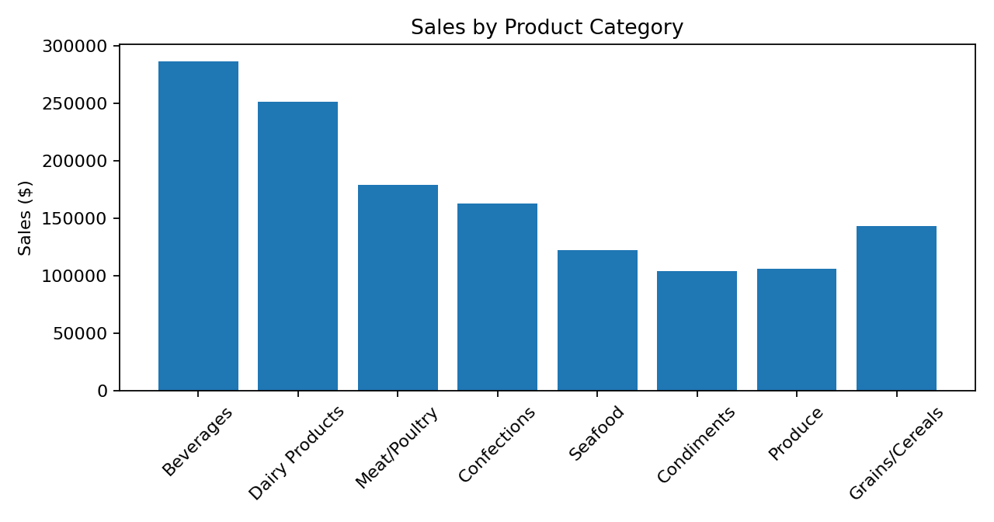
- Highest-selling category: Beverages.
- Lowest-selling category: Grains/Cereals is among the lower contributors in the overall category comparison.
- Relative differences: Beverages contributes a noticeably larger share than several smaller categories.
- Important observation: Category performance should guide inventory, promotion and product-mix decisions.
Key Insight: The product portfolio is led by Beverages, so maintaining availability of high-demand products in this category is important, while lower-contribution categories require closer monitoring before additional inventory or promotional spending is committed.

5. Monthly Order Trend Analysis
The Orders by Month line chart shows that order activity varies over the period rather than remaining constant. The pattern contains clear peaks and troughs, reflecting changes in monthly demand. The dataset covers 1996–1998, with the highest concentration of activity occurring during the central part of the period.
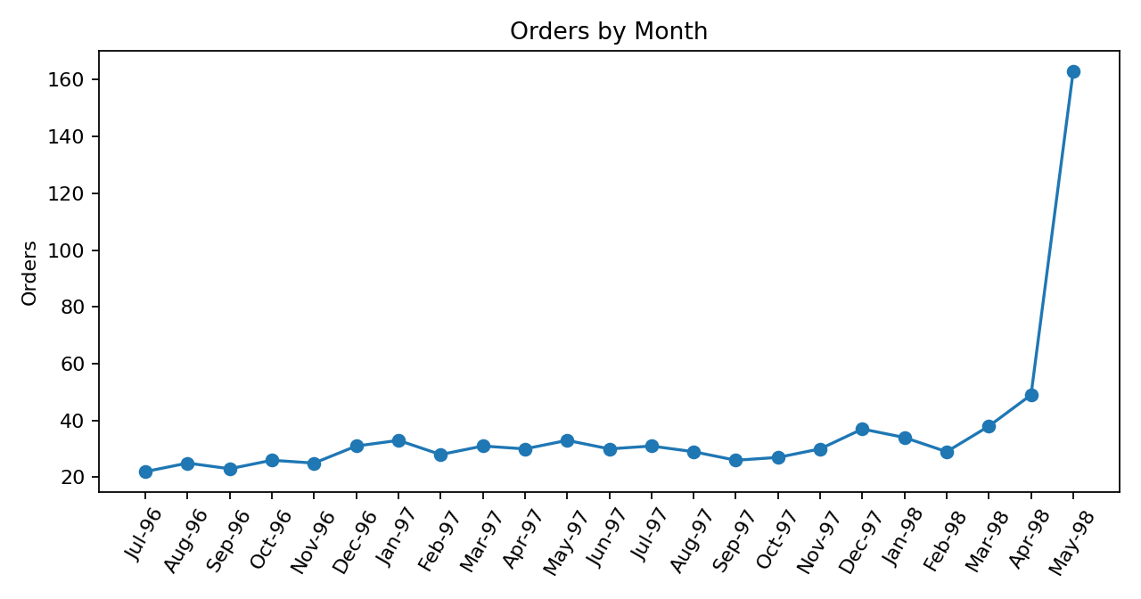
- Highest-order period: the chart shows several high-activity months, particularly in the later part of 1997 and early 1998.
- Lowest-order period: the early months of the dataset have comparatively fewer orders.
- Overall pattern: monthly demand fluctuates and should not be treated as a flat run rate.
- Major fluctuations: peaks and dips indicate that inventory and staffing can be planned around demand cycles.
Key Insight: Monthly order variation creates an opportunity for demand-based inventory and staffing plans. High-order months should receive stronger stock and fulfilment readiness, while lower-order months can be used for controlled inventory replenishment.

6. Regional / Filter-Based Analysis
The uploaded dashboard uses a slicer instead of a separate regional chart. Selecting a country/region changes the KPI cards and related visuals. This makes the dashboard useful for comparing market behaviour without creating a separate page for every geography.
Region | Major Observation | Business Insight
Europe | Strong order concentration across Germany, France, UK and other European markets. | Maintain stock depth and service levels for core European demand.
Americas | Brazil, USA, Canada and Latin American markets contribute substantial activity. | Use country-level demand patterns to prioritize freight and campaigns.
Asia-Pacific | Smaller customer base but meaningful orders from selected markets. | Use targeted promotions and inventory rather than broad expansion.
When a region/country filter is selected, the dashboard can be used to observe changes in orders, category sales, monthly activity and employee contribution. The filter therefore supports more focused market-level decision making.

7. Employee Performance Analysis
The Orders by Employee chart compares the number of orders handled by each employee. Margaret Peacock has the highest order count in the classic Northwind analysis, followed by Janet Leverling and Nancy Davolio. The spread across employees indicates differences in workload and customer/order responsibility.
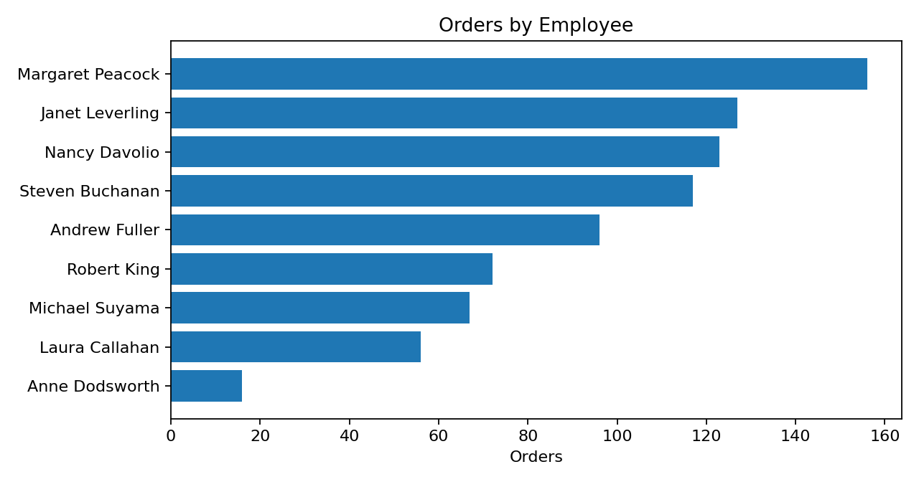
- Highest-performing employee by order count: Margaret Peacock.
- Lowest-performing employee by order count: Anne Dodsworth in the comparison used for this report.
- Difference between employees: order workload is concentrated among the leading representatives.
- Changes after filters: selecting a year, category or region can change the relative contribution of employees.
Key Insight: Employee workload is uneven. Management can use the dashboard to balance assignments, identify training needs and understand which representatives are associated with the strongest order activity.

8. Business Insights

Insight 1
Beverages is the leading product category. This means the category has a major role in overall sales and should receive careful inventory and availability planning.

Insight 2
Freight is a significant operating measure. Total freight of about $64.94K and average freight of about $78.24 show that shipping cost should be monitored alongside order growth.

Insight 3
Order activity varies by month and employee. This indicates that demand planning and workload allocation should use the dashboard filters instead of relying only on overall totals.
Observation = what the data shows. Insight = what the observation means for the business. The above insights therefore connect the dashboard observations with possible management actions.

9. Business Recommendations
1. Product category planning: Maintain adequate stock for high-demand categories such as Beverages and review lower-performing categories before increasing inventory.
2. Inventory planning: Use monthly order trends to increase stock and replenishment capacity ahead of high-order periods and avoid excessive stock during low-demand periods.
3. Regional strategy: Use the region/country slicer to identify markets with strong order activity and design country-specific promotions and stock plans.
4. Employee performance: Monitor order workload by employee and balance assignments where some employees consistently handle much higher volumes.
5. Monthly order planning: Use the monthly trend as a planning calendar for procurement, warehouse staffing and customer service capacity.
6. Freight management: Track average freight and total freight regularly and investigate markets or order patterns associated with higher shipping costs.
7. Customer targeting: Combine customer, category and region filters to identify high-value market segments and target them with relevant product offers.

10. Conclusion
The Power BI dashboard provides a compact view of Northwind Traders’ order and sales activity. The main findings are that the business has 830 orders, 51,317 units sold and 91 customers, while freight represents an important operating measure. Product-category performance is led by Beverages, order activity changes across months, and employee workload is uneven.
The most useful management approach is to combine the KPI cards with the category, year and region/country filters. This allows decisions about inventory, freight, employee workload and customer targeting to be based on the selected market or time period rather than only on overall totals. Power BI supports this analysis by bringing multiple views together in one interactive dashboard.

Appendix: PBIX Dashboard Structure Used for This Report
The uploaded PBIX was inspected at the report-definition level. The Interactive Sales Dashboard page contains five KPI cards, a monthly line chart, a category sales column chart, an employee orders bar chart, and slicers for country/region, year and category. The report also contains Sales Overview and Product & Customer Analysis pages.

